C:\Users\sonia\AppData\Local\Microsoft\Windows\Temporary Internet Files\Low\Content.IE5\I0997A6R\bd05203_[1].wmf 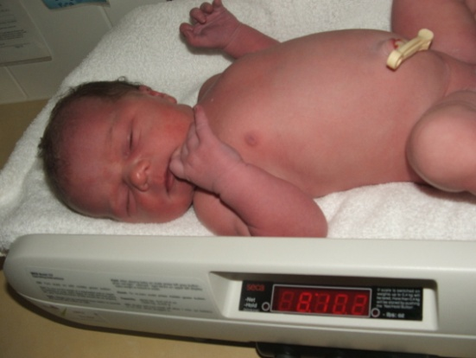

Bodyweight birthweight

**Biological Determinants**

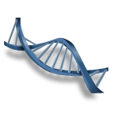

Genetics

PC:\Users\sonia\AppData\Local\Microsoft\Windows\Temporary Internet Files\Low\Content.IE5\FSAQWPIT\j0396710[1].wmf C:\Users\sonia\AppData\Local\Microsoft\Windows\Temporary Internet Files\Low\Content.IE5\I0997A6R\pe03131_[1].wmf C:\Users\sonia\AppData\Local\Microsoft\Windows\Temporary Internet Files\Low\Content.IE5\LMJ77OVK\j0272024[1].wmf

dsjfajsndfj

Breastfeeding

Vaccination

Physical activity

P

P

Phy

C:\Users\sonia\AppData\Local\Microsoft\Windows\Temporary Internet Files\Low\Content.IE5\I0997A6R\j0360736[1].wmf**Behavioural Determinants** **C:\Users\sonia\AppData\Local\Microsoft\Windows\Temporary Internet Files\Low\Content.IE5\FSAQWPIT\bd09489_[1].wmf**

Oral hygiene

Maternal behaviours (nutrition, alcohol & drug use) during pregnancy

**C:\Users\sonia\AppData\Local\Microsoft\Windows\Temporary Internet Files\Low\Content.IE5\LMJ77OVK\j0356451[1].wmf** **C:\Users\sonia\AppData\Local\Microsoft\Windows\Temporary Internet Files\Low\Content.IE5\A4HZGLAH\j0356453[1].wmf** C:\Users\sonia\AppData\Local\Microsoft\Windows\Temporary Internet Files\Low\Content.IE5\A4HZGLAH\j0396740[1].wmf

Eating habits

Jhbsdkjflkdf

Sun protection behaviours

**C:\Users\sonia\AppData\Local\Microsoft\Windows\Temporary Internet Files\Low\Content.IE5\A4HZGLAH\j0290955[1].wmf C:\Users\sonia\AppData\Local\Microsoft\Windows\Temporary Internet Files\Low\Content.IE5\ZGOV0JDQ\j0391412[1].wmf**

Housing environment

Tobacco smoke in the home

**Physical environment**

**C:\Users\sonia\AppData\Local\Microsoft\Windows\Temporary Internet Files\Low\Content.IE5\91R9ASYB\j0291104[1].wmf C:\Users\sonia\AppData\Local\Microsoft\Windows\Temporary Internet Files\Low\Content.IE5\FSAQWPIT\j0234567[1].wmf**

Fluoridation of the water supply

Recreational facilities

**C:\Users\sonia\AppData\Local\Microsoft\Windows\Temporary Internet Files\Low\Content.IE5\FSAQWPIT\j0397612[1].wmf ** **C:\Users\sonia\AppData\Local\Microsoft\Windows\Temporary Internet Files\Low\Content.IE5\I0997A6R\j0428331[1].wmf**

Parental occupation

Parental income

Parental education level

**Social Environment (family)**

**C:\Users\sonia\AppData\Local\Microsoft\Windows\Temporary Internet Files\Low\Content.IE5\FSAQWPIT\j0088756[1].wmf** **C:\Users\sonia\AppData\Local\Microsoft\Windows\Temporary Internet Files\Low\Content.IE5\NBMNPE3Y\bd20150_[1].wmf** C:\Users\sonia\AppData\Local\Microsoft\Windows\Temporary Internet Files\Low\Content.IE5\LMJ77OVK\bd09503_[1].wmf

Family & work life balance

Family stress and trauma

Parental health and disability

**C:\Users\sonia\AppData\Local\Microsoft\Windows\Temporary Internet Files\Low\Content.IE5\I0997A6R\pe03673_[1].wmf**

Parenting practices

**C:\Users\sonia\AppData\Local\Microsoft\Windows\Temporary Internet Files\Low\Content.IE5\LMJ77OVK\j0351240[1].wmf** **C:\Users\sonia\AppData\Local\Microsoft\Windows\Temporary Internet Files\Low\Content.IE5\91R9ASYB\j0286890[1].wmf**

Neighbourhood safety

Media

**Social Environment (community)**

**C:\Users\sonia\AppData\Local\Microsoft\Windows\Temporary Internet Files\Low\Content.IE5\ZGOV0JDQ\j0436007[1].wmf C:\Users\sonia\AppData\Local\Microsoft\Windows\Temporary Internet Files\Low\Content.IE5\I0997A6R\j0289970[1].wmf**

Access to childcare and preschool

Access to health care

**C:\Users\sonia\AppData\Local\Microsoft\Windows\Temporary Internet Files\Low\Content.IE5\V03RQ95B\j0436129[1].wmf** **C:\Users\sonia\AppData\Local\Microsoft\Windows\Temporary Internet Files\Low\Content.IE5\91R9ASYB\pe06219_[1].wmf**

Access to social support

Access to school

**Activity 1**

1. Select 2 examples of each determinant and explain how they can have a positive impact on the physical, social and/or mental health of children
2. Select 2 examples of each determinant and explain how they can have a negative impact on the physical, social and/or mental health of children

**Activity 2**

Select 2 examples of each determinant (at least one that is different to activity 1) and explain how they can impact on the physical, social, emotional and/or intellectual development of children.